IST 659 Lab 3

Part 1: Logical Modeling Case Studies

Sol:

Case Study 1:

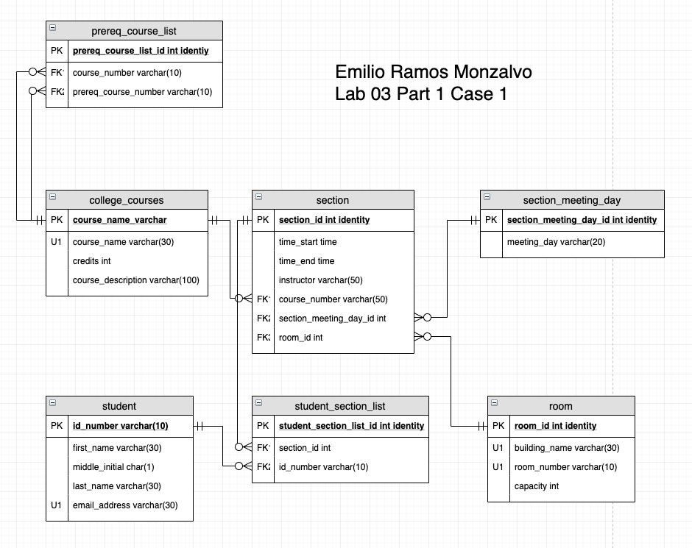

Case Study 2:

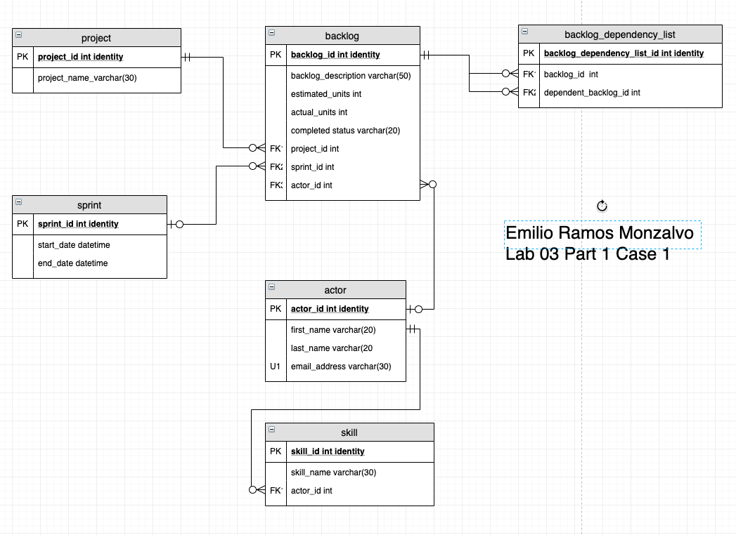

Case Study 3:

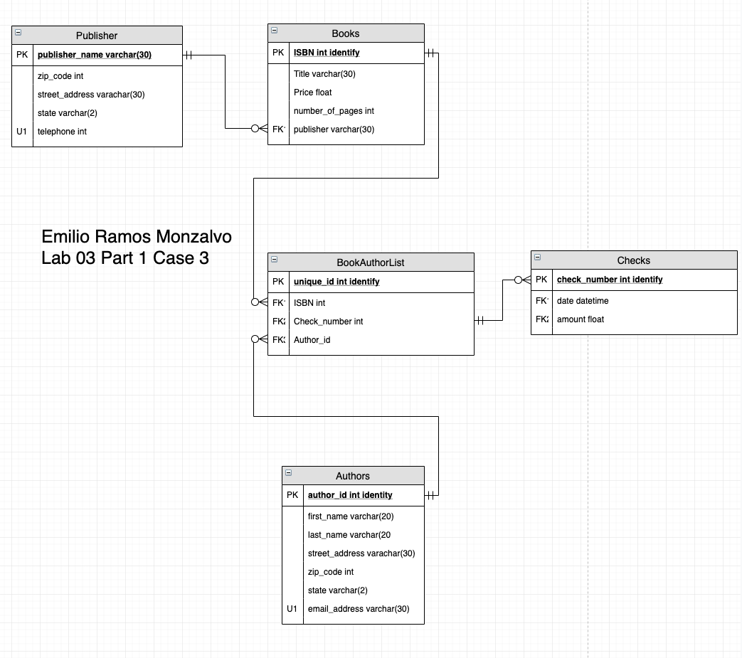

Part 2: VidCast Logical Model

Sol:

